

2nd Beaver Bank
"B" Pack
June 9th & 10th
Closing Camp
INFORMATION SHEET

Our camp will be held in the meadow at the bottom of Grove Ave.
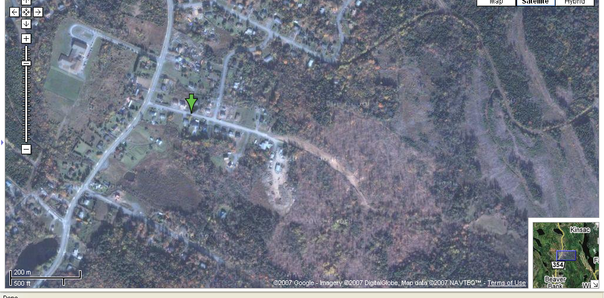

The long range forecast shows partly cloudy and around 15C for that weekend, so you should be able to drive right down the hill (ie. not too muddy). Youth should be dropped off wearing their uniforms at 10am on Saturday.

Please be aware that everyone will be sleeping in tents (boys separate from girls separate from leaders). The ground is not rocky, but it is still hard ground, so be prepared with sleeping bag and padding. There is an outhouse at this location, but no drinking water so be sure to pack a water bottle or two.

Camp will officially close at 1:00pm Sunday afternoon, and parents and family are encouraged to arrive 10-15 minutes early to join us for our closing ceremony which will include some award presentations.

CAMP FEES
Camp fees are $20 per youth.
In order to arrange equipment and buy enough groceries for camp, we need to know how many youth will be attending the camp. Please confirm, with payment, to Akela at a meeting or in person (1133 Susan Drive, 252-5783) no later than June 5.
Also please confirm if you know for certain that you are not able to attend.
Emergency Phone at camp: (my cell) 452-4532

MENU (parents please check to ensure we have no issues with allergies!!)
“lunch” – hot dogs & bannick (bread cooked on a stick)
“supper” – “tinfoil meals” hamburger, potatoes, carrots, onion (blah!)
“Mug Up” – s’mores (chocolate, marshmallow, graham crackers)
“Breakfast” – assorted breakfast cereals, milk, oatmeal
“snack” – trail mix (nuts, dried fruit, seeds, yogurt raisins, etc)
“lunch” – tomato paste, assorted meats, cheese, dough
We will also have bread, margarine, peanut butter and jam on hand – just in case.

PERSONAL GEAR

The following is a list of gear cubs should be bringing to camp.

ITEM | Marked With Name | Packed
Uniform (shirt, sash, necker, woggle)
Cub Book
Coat or warm jacket
Hat
Survival pouch (if you have one, as per Cub Book)
Warm waterproof boots
2 shirts
2 pants
3 pairs of socks
3 pair underwear
1 sweatshirt
Pajamas
Sleeping bag
Sleeping pad (for under sleeping bag)
Pillow
Rain gear (weather?)
Campfire blanket
Sleeping buddy (if you want)
Toothbrush and toothpaste
Flashlight with batteries

Please feel free to bring along items that are not on this list if it will help your child feel more comfortable. BUT! The following items are NOT ALLOWED:
Matches, knives, etc (unless kept in survival pouch)
ANY electronics (video games, radios, etc.)

